Casing Modifications for fitting LSD in to BMW 2002 and Early E21 casings

Before casing modification can begin please ensure side bearings are fitted as well as the crownwheel with All the crownwheel bolts fitted.
It is also recommended that the pinion is removed and the hole blocked to ensure cleanliness.

- Cut out templates and fold as shown on template sheet

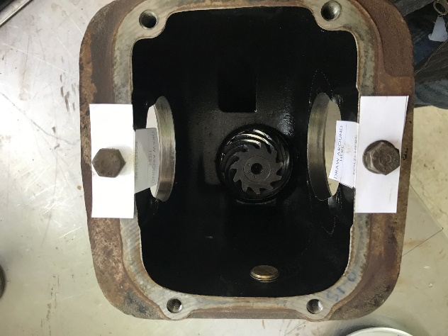
- Offer up to casing and hold in place using rear cover bolts
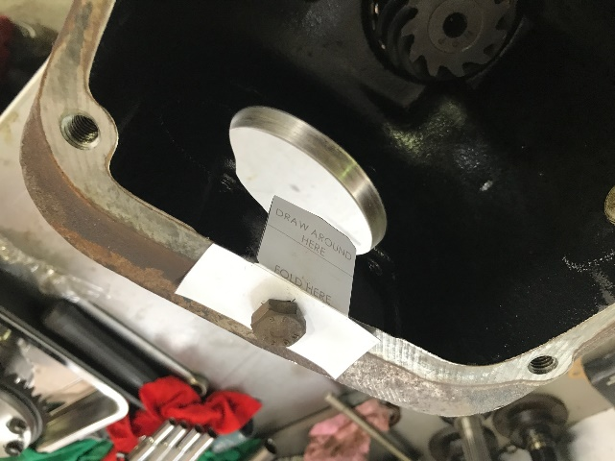

- Draw around template to show area that needs modification

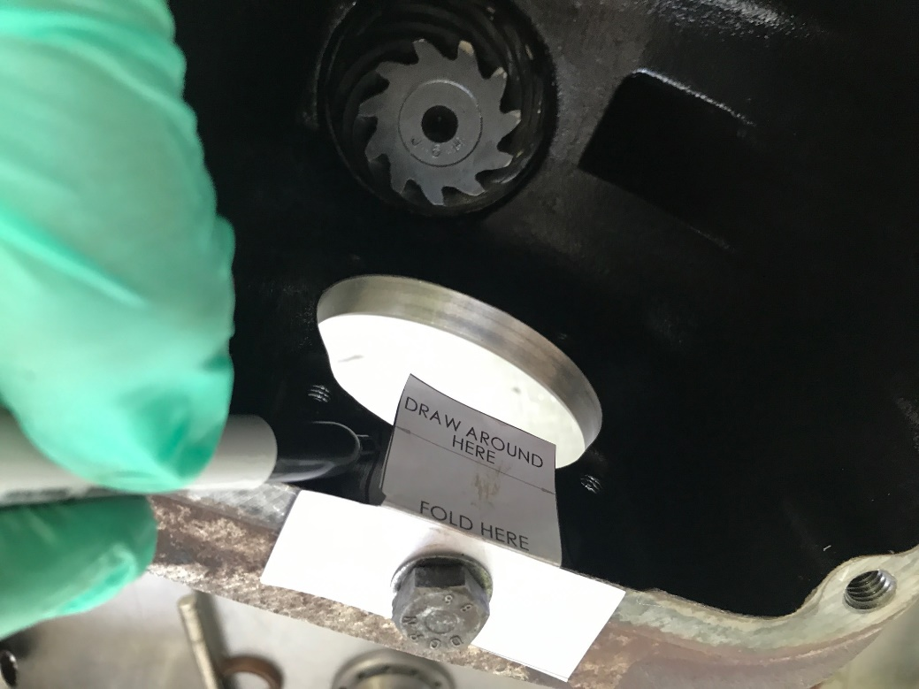

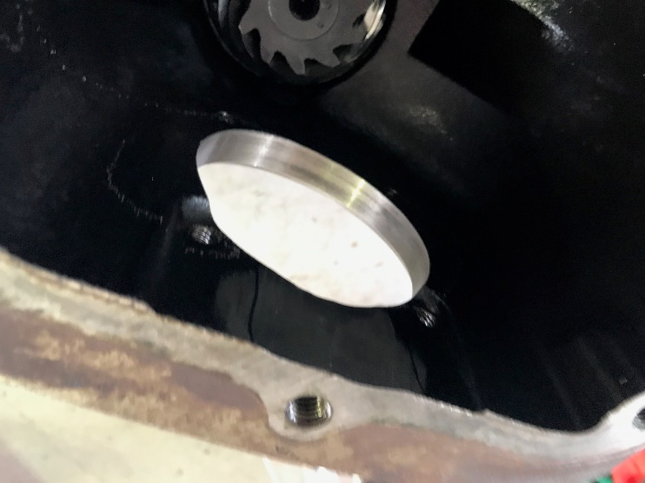
- Using a grinder modify casing as required. Approximately 1-2mm will need to be removed from each side of the casing. Keep checking fitment as you go until just enough material has been taken out.
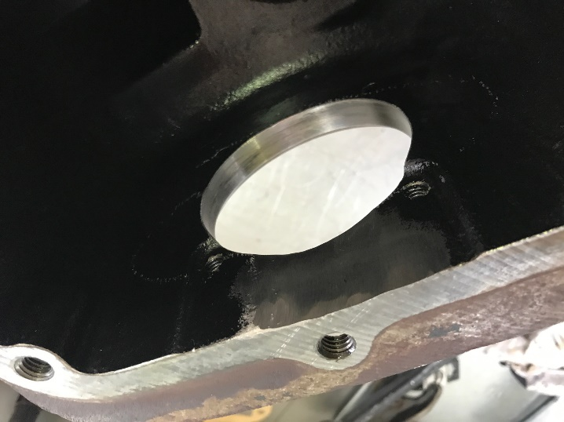

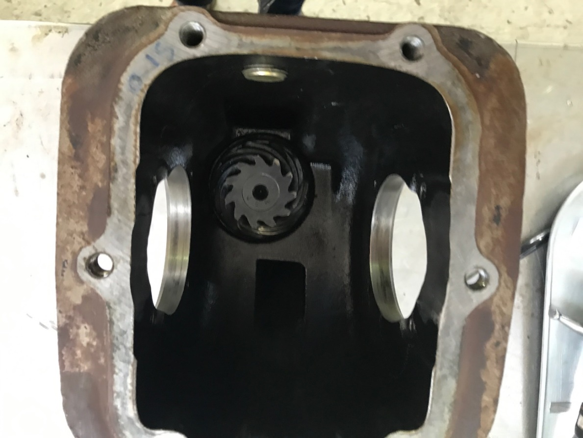

- Thoroughly clean casing by blowing out with air and flushing with cleaning fluid to ensure all debris has been removed.

- The diff unit can now be fitted as normal adhering to manufactures manual and ensuring correct set up tolerances.

